Pizza Sales Analysis Using SQL and Excel

# Agenda

1. Firing in some queries into MS SQL Server (MSS)
2. Import the data into MSS.
3. Creating the database
4. Writing the Queries
5. Creating the report
6. Connecting the excel to MSS
7. Data Cleaning
8. Data Processing
9. Data Analysis
10. Data Visualization
11. Creating the dashboard

# Problem Statement

* We need to analyze key indicators for our pizza sales data to gain insights into our business performance.
* We need to calculate the following metrics.

1. Total Revenue: The sum of order price of all pizza orders
2. Average Order Value: The average amount spent per order, calculated by dividing the total revenue by the total number of orders.
3. Total orders: The total number of orders placed.
4. Total Pizzas sold: The sum of the quantities of all the pizzas sold.
5. Average Pizzas per order: The average number of pizzas sold per order, calculated by dividing the total number of pizzas sold by total number of orders.

# Chart Requirements:

1. Daily trend for total orders: Create a bar chart that displays the daily trend of total orders over a specific time period. This chart will help us to identify any patterns or fluctuations in order volumes daily.
2. Hourly trend for total orders: Create a line chart that illustrates the hourly trend of total orders throughout the day. This chart will allow us to identify peak hours or periods of high order activity.
3. Percentage of sales by pizza category: Create a pie chart that shows the distribution of sales categories. The chart will provide insights into the popularity of various pizza categories and their distribution to overall sales.
4. Percentage of sales by pizza size: Generate a pie chart that will represent the percentage of sales attributed to different pizza sizes. This chart will help us understand customer preferences for pizza sizes and their impact on sales.
5. Total pizzas sold by pizza category: Create a funnel chart that will represent the total number of pizzas sold for each pizza category. This chart will allow us to compare the sales performance of different pizza categories.
6. Top 5 best sellers by total pizza sold: Create a bar chat highlighting the top 5 bestselling pizzas based on the total number of pizzas sold. This chart will help us identify the most popular pizza options.
7. Bottom 5 worst sellers by total pizzas sold: Create a bar chart showcasing the bottom 5 worst selling pizza based on the total number of pizzas sold. This chart will enable us to identify less popular pizza options.

# Writing the sql queries for different charts

* First of all we will import our csv file in MSS, after importing the file in MSS we found that the data types were automatically assigned which were not appropriately assigned so we have to change the data type manually like for order id column the original data type assigned was small int which was throwing an error later so we changed it to the int type. And same for the order id column.
* To check if the data is added correctly or not in the MSS we will write the “select * from pizza sales” and later execute it.
* To fetch “Total Revenue” we will write “SELECT SUM(total_price) AS Total_Revenue from pizza_sales” query in the MSS.

* To determine the average order value, we will write the “SELECT SUM(total_price) / COUNT(DISTINCT order_id) AS Avg_Order_Value FROM pizza_sales” sql query

* Similarly, to find the total pizza sold we will write “SELECT SUM(quantity) AS Total_Pizza_Sold FROM pizza_sales”

* To find the total number of orders we will the following sql query” SELECT COUNT(DISTINCT order_id) AS Total_orders from pizza_sales”

* To find the average pizzas per order we will write the following query “SELECT CAST(SUM(quantity) AS DECIMAL (10,2)) /CAST(COUNT(DISTINCT order_id) AS DECIMAL(10,2)) AS Avg_Pizzas_per_order from pizza_sales” here it may happen that the count that we get might be in decimals hence we are type casting the sum of quantity.

* Now we will write the sql queries to get the values for our charts so as per our first requirements for our charts we will be calculating values for daily trends for our orders “SELECT DATENAME(DW,order_date) as order_day, COUNT(DISTINCT order_id) AS Total_orders from pizza_sales GROUP BY DATENAME(DW,order_date) ”

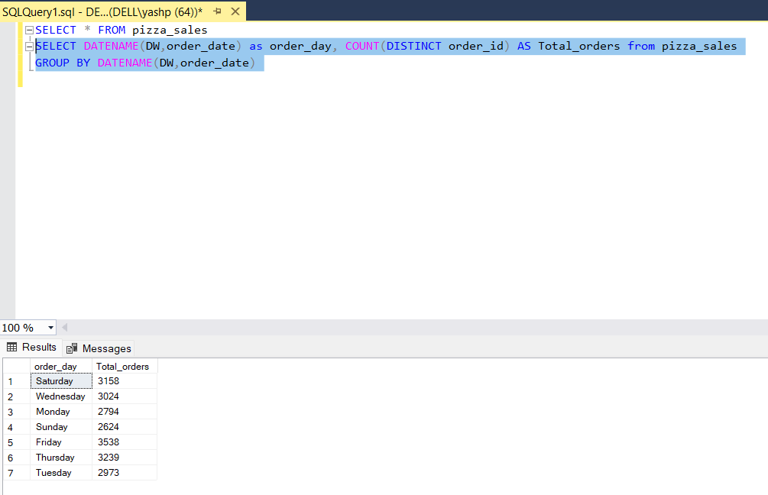

* Similarly, for hourly trend our sql query will be as below

“SELECT DATEPART(HOUR, order_time) AS order_hours, COUNT (DISTINCT order_id) AS Total_orders

from pizza_sales

GROUP BY DATEPART(HOUR, order_time)

ORDER BY DATEPART(HOUR, order_time)”

* Next is the query for percentage of the sales by pizza category will be as below.

“SELECT pizza_category, SUM(total_price) as Total_Sales, SUM(totaL_price) * 100 / (SELECT sum(total_price) from pizza_sales where MONTH(order_date) = 1) AS PCT

from pizza_sales

where MONTH(order_date) = 1

GROUP BY pizza_category”

* Next is the query for percentage of sales by pizza size the query is as below.

“SELECT pizza_size, CAST(SUM(total_price) AS DECIMAL (10,2)) as Total_Sales, CAST(SUM(totaL_price) * 100 / (SELECT sum(total_price) from pizza_sales WHERE DATEPART (quarter,order_date)=1) AS DECIMAL (10,2)) AS PCT

from pizza_sales

WHERE DATEPART (quarter,order_date)=1

GROUP BY pizza_size

ORDER BY PCT DESC”

* Moving further the query for the total sales of pizza by pizza category

SELECT pizza_category, sum(quantity) as Total_Pizzas_Sold

from pizza_sales

group by pizza_category

* Top 5 best seller by total pizzas sold

SELECT TOP 5 pizza_name, sum(quantity) as Total_Pizzas_Sold

from pizza_sales

GROUP BY pizza_name

ORDER BY sum(quantity) DESC

* Similarly for bottom 5 the query will be

SELECT Top 5 pizza_name, sum(quantity) as Total_Pizzas_Sold

from pizza_sales

GROUP BY pizza_name

ORDER BY sum(quantity) ASC

Creating the dashboard with excel

# Data Cleaning in excel

* After import importing the data from the sql server into Microsoft excel we have to perform the data cleaning.
* In the data cleaning step the very first thing that we have done was renaming the pizza size abbreviations “M”,”L”,”S”,”XL”,”XXL” as “Medium”, ”Large”, ”Regular”, “Extra-large”, “Excess large” respectively.

# Data Processing

* The very first step in data preprocessing that we will be doing is extracting the day from the order date column.
* For the above step we will use various tools or formulas “=TEXT([@[order_date]],"dddd")”
* Also we will add the “total orders” column and write the below formula

“=1/COUNTIF(B:B,[@[order_id]])” to convert the order id column to distinct values (total orders column).

# Data Analysis

* To determine the average order value we have to take the ratio of total revenue by total number of orders in excel we will use the “=GETPIVOTDATA ("Sum of total_price",$A$3)/GETPIVOTDATA("Sum of total_orders",$A$3)” formula.
* For calculating average pizzas per order in excel we will write the below “=GETPIVOTDATA ("Sum of quantity",$A$3)/GETPIVOTDATA("Sum of total_orders",$A$3)”
* After Validating all the 5 attributes that is total revenue, total orders, total pizzas sold, Average Order Value, Average pizzas per order with that of the sql queries we have written earlier we have found out that the results are same.

* Now we will create visuals charts for each of our components.
* To create a funnel chart for total number of pizzas by pizza category there was an error showing that we cannot create a funnel chart for the data inside the pivot table.
* So, for that we have to just pull out the data from the pivot table so for that we have to create a separate table for pizza category and total pizza sold.
* Then moving further, we have to select that particular table that we have just created, go to insert option and select funnel chart.